Homework 4

# Problem I (Encoder, Decoder)

The OR gates select the higher priority when they are Y4..Y7. Then the A bit is from the OR of Y4..7. The D bit is from the or of Y0..7. B and C are encoded from the selection of the 4:2 encoders from a mux that is selected by the Y4..7 Or.

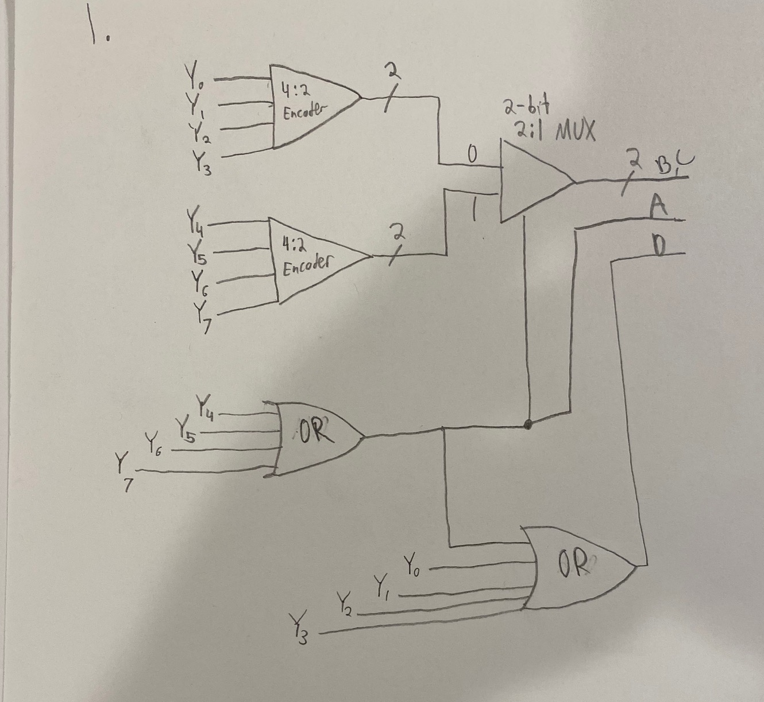

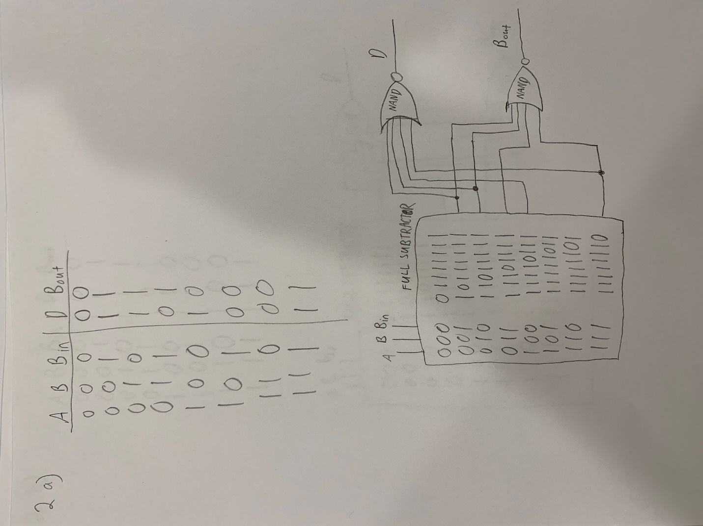

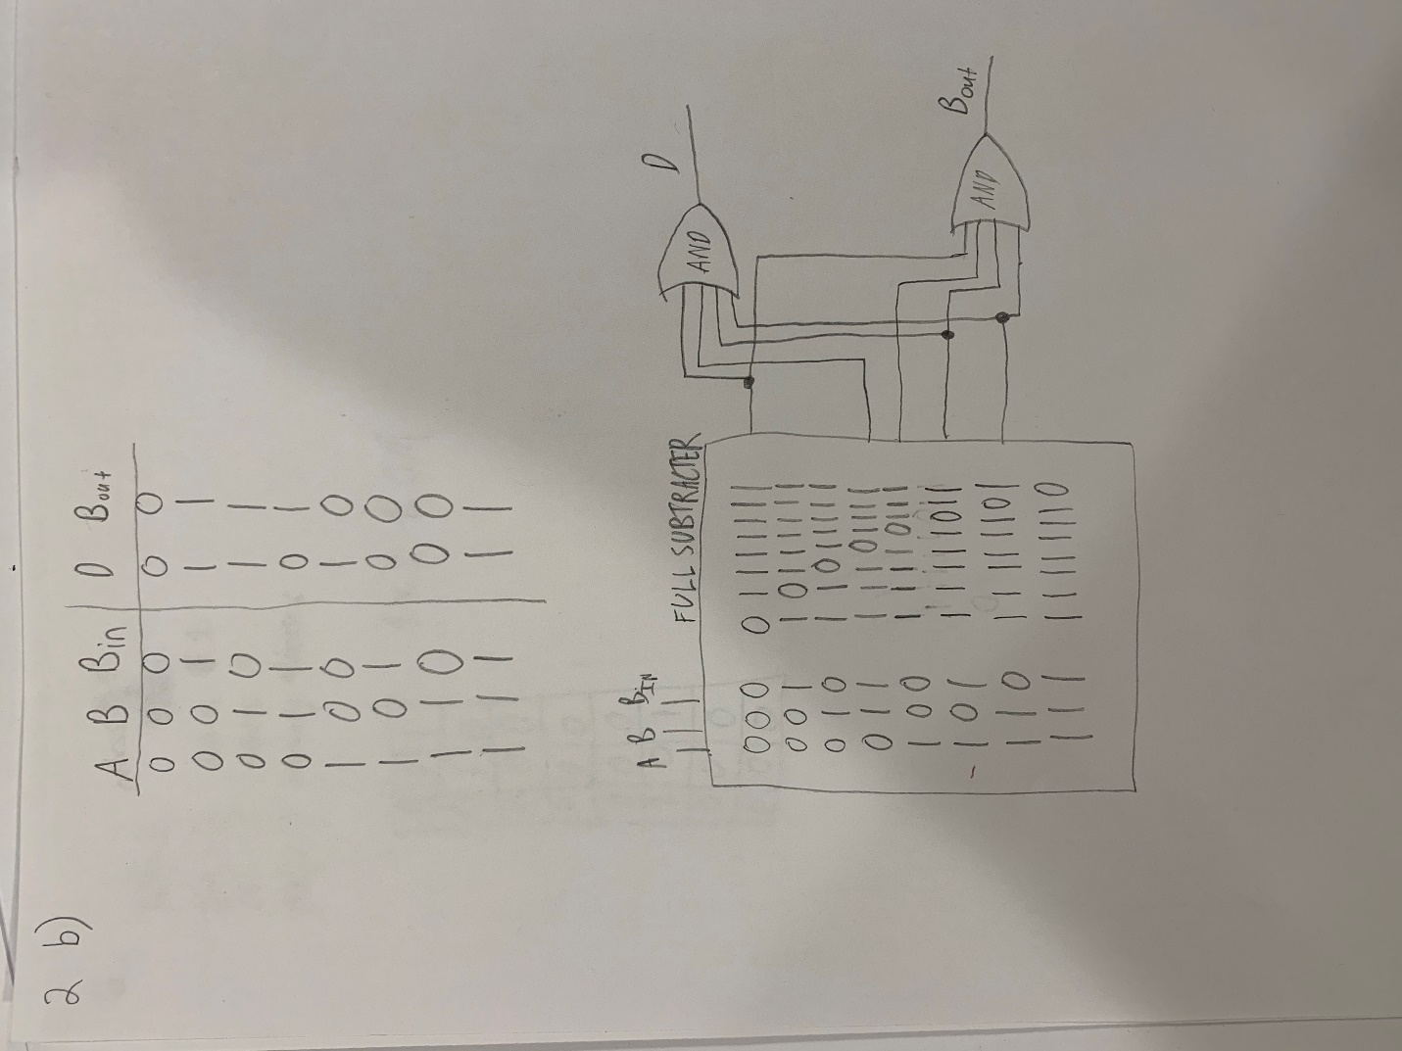

# Problem II (Multiplexer, Demultiplexer)

Truth Table and then combining the minterms where A could be either a 1 or a 0. So minterm 0 and 16, 1 and 17, 2 and 18, 3 and 19, 4 and 20, 5 and 21, 6 and 22, 7 and 23, 8 and 24, 9 and 25, 10 and 26, 11 and 27, 12 and 28, 13 and 29, 14 and 30, 15 and 31.



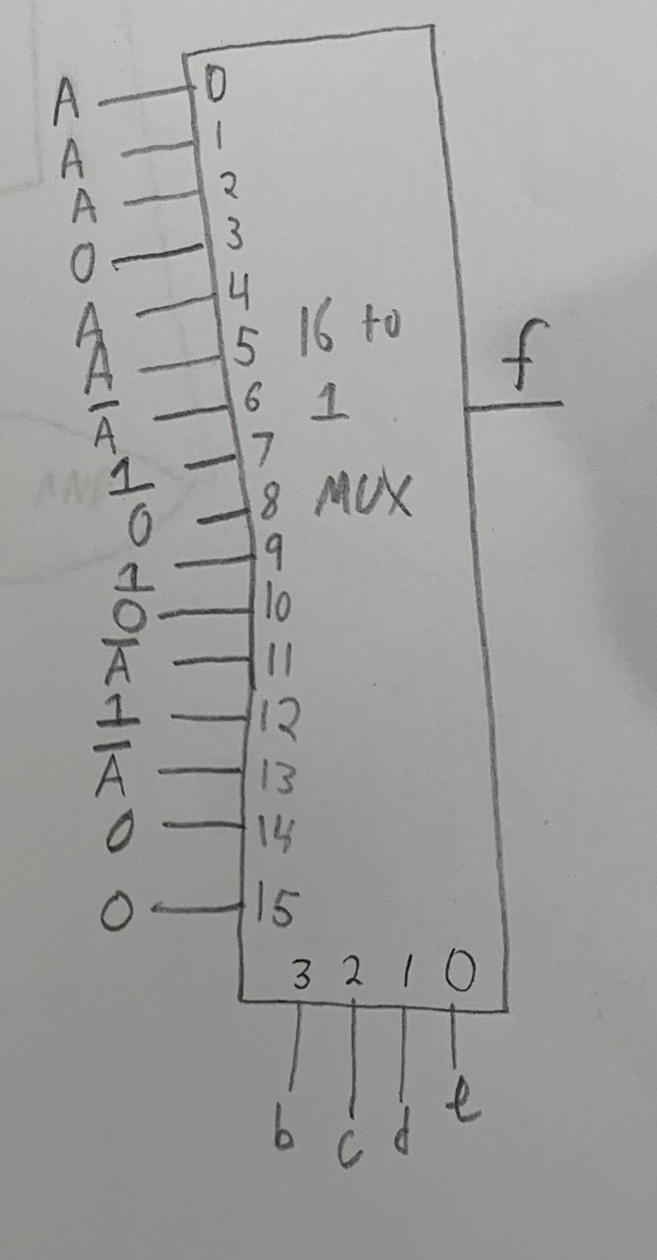

# Problem III (Memory)

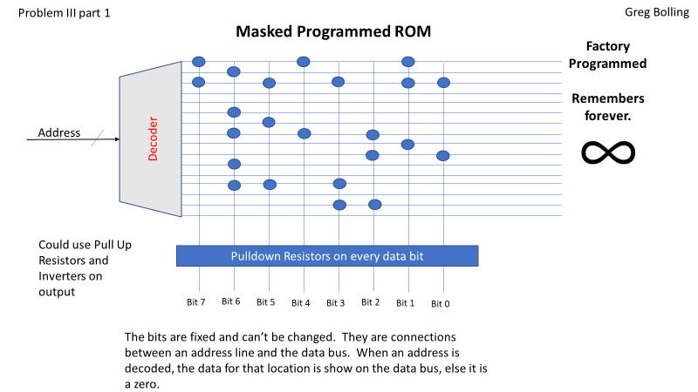

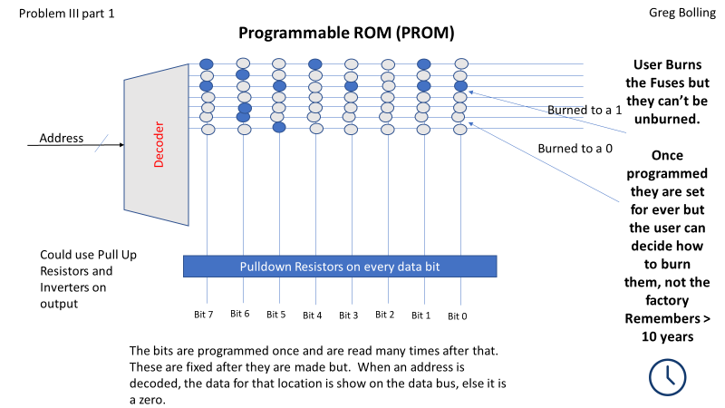

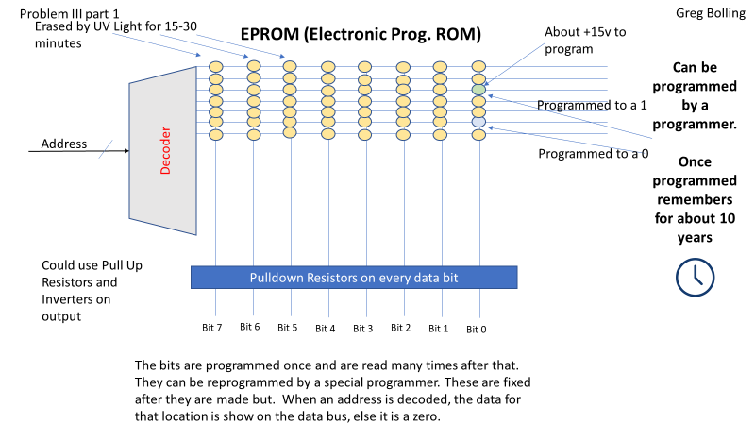

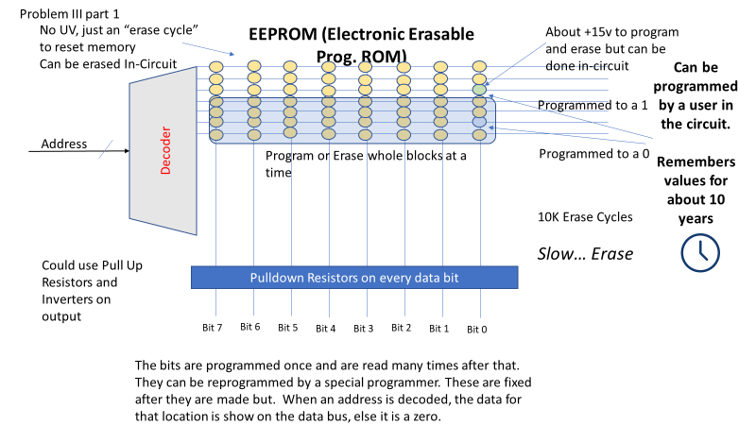

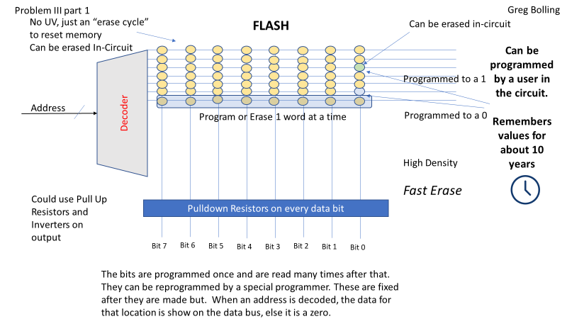

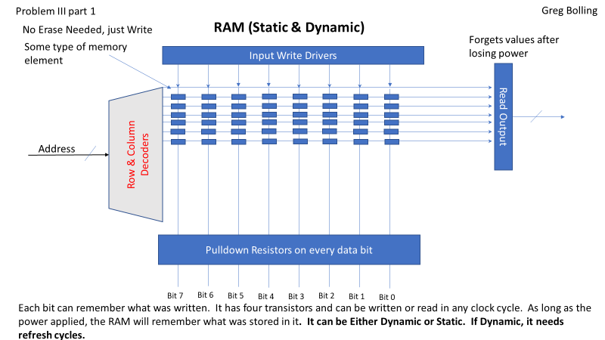

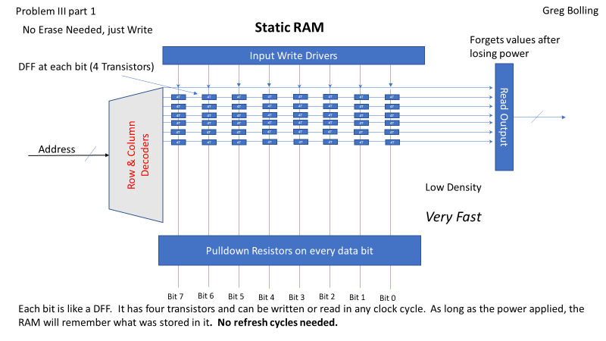

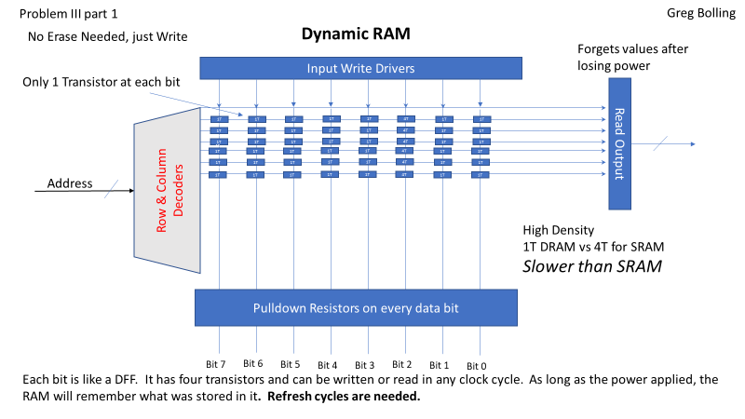

Problem 3 Part 2

ROM contents

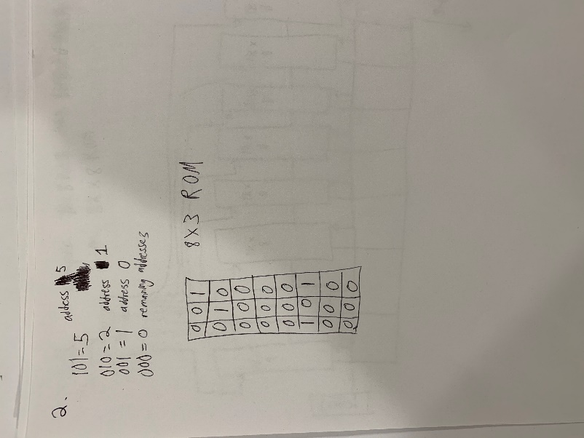

Diagram for Problem 3 Part 2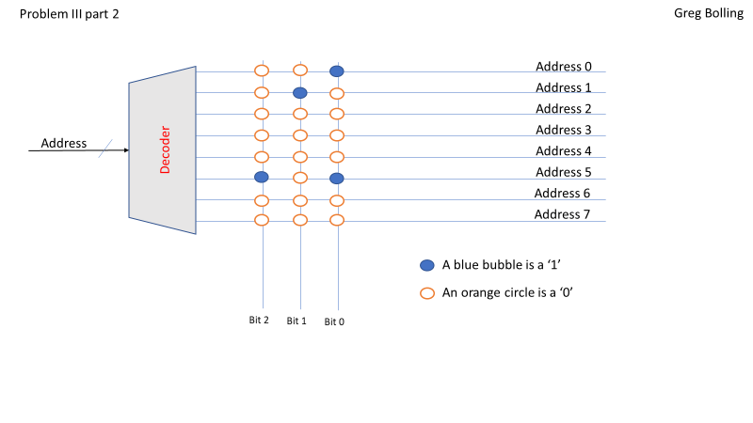

Diagram for Problem 3 Part 3

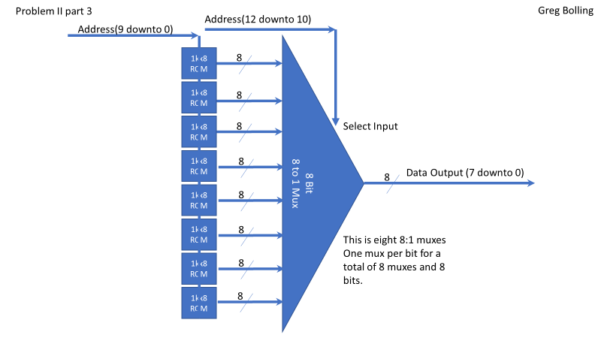

RAM Usage of Problem 3 Part 4

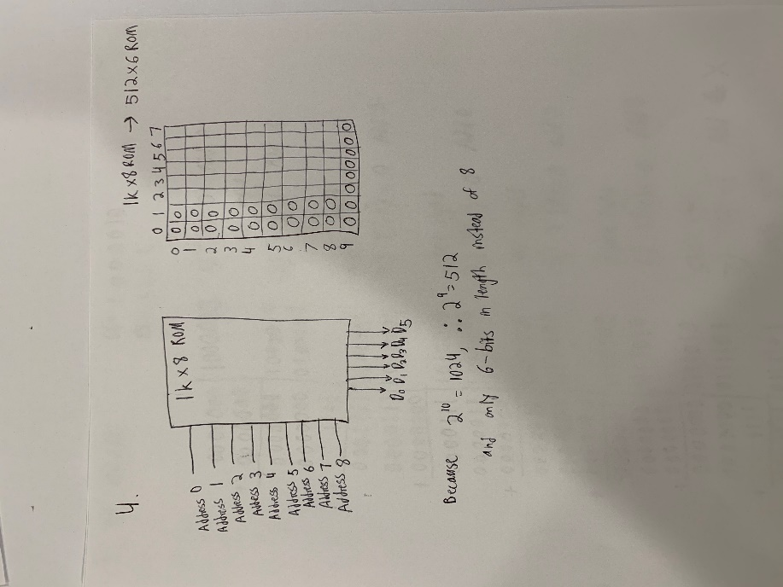

Diagram for Problem 3 Part 4

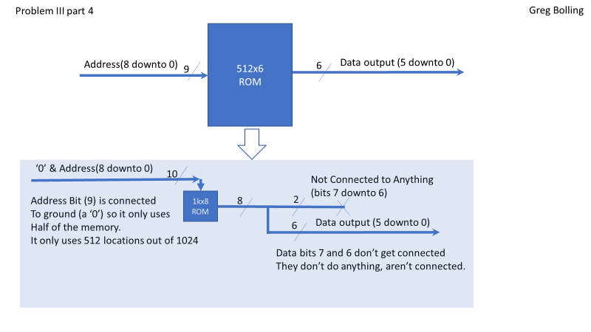

Problem IV (Arithmetic)

Use the shift and add algorithm 15x66

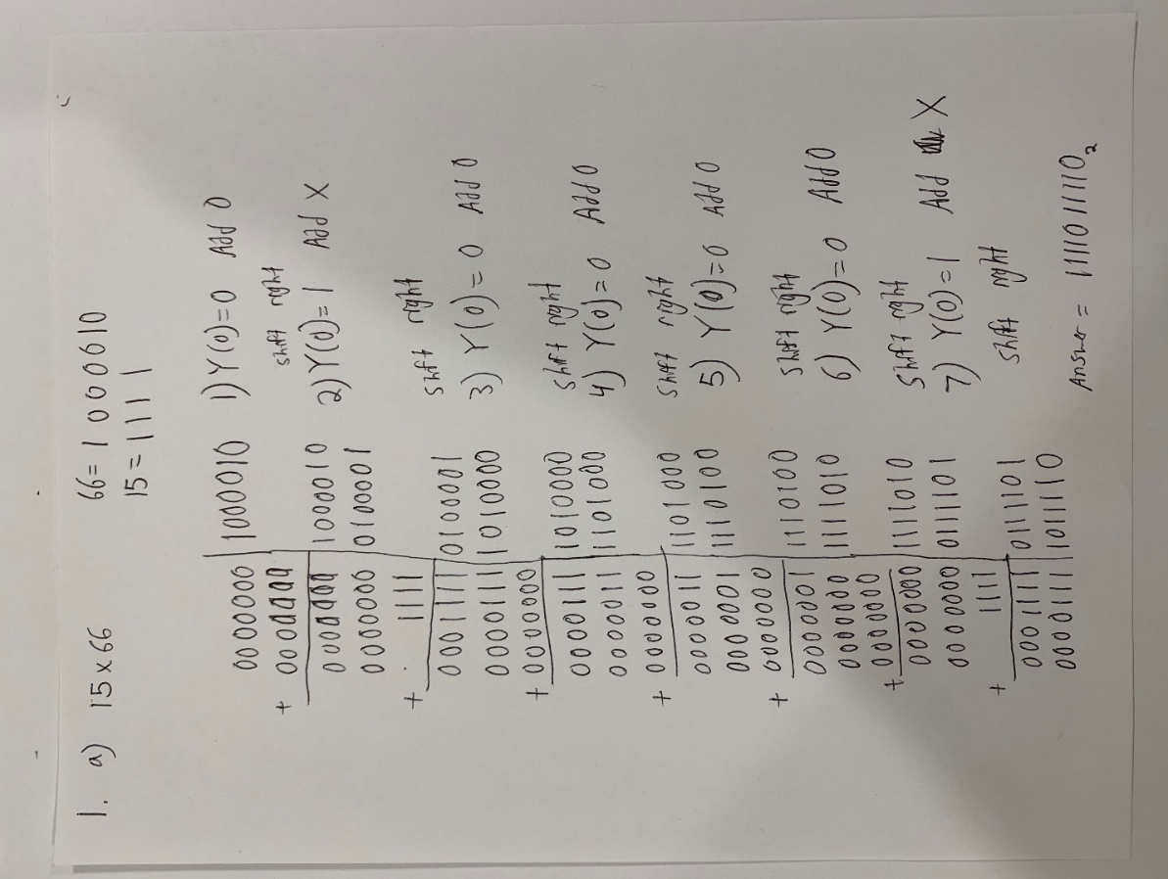

Use the shift and add algorithm (-55) x (-35)

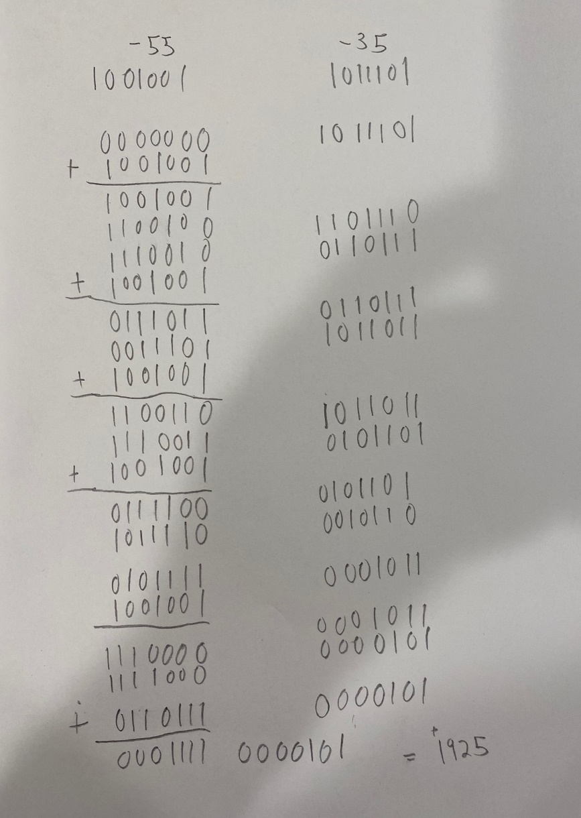

Use the shift and add algorithm 40 x (-16)

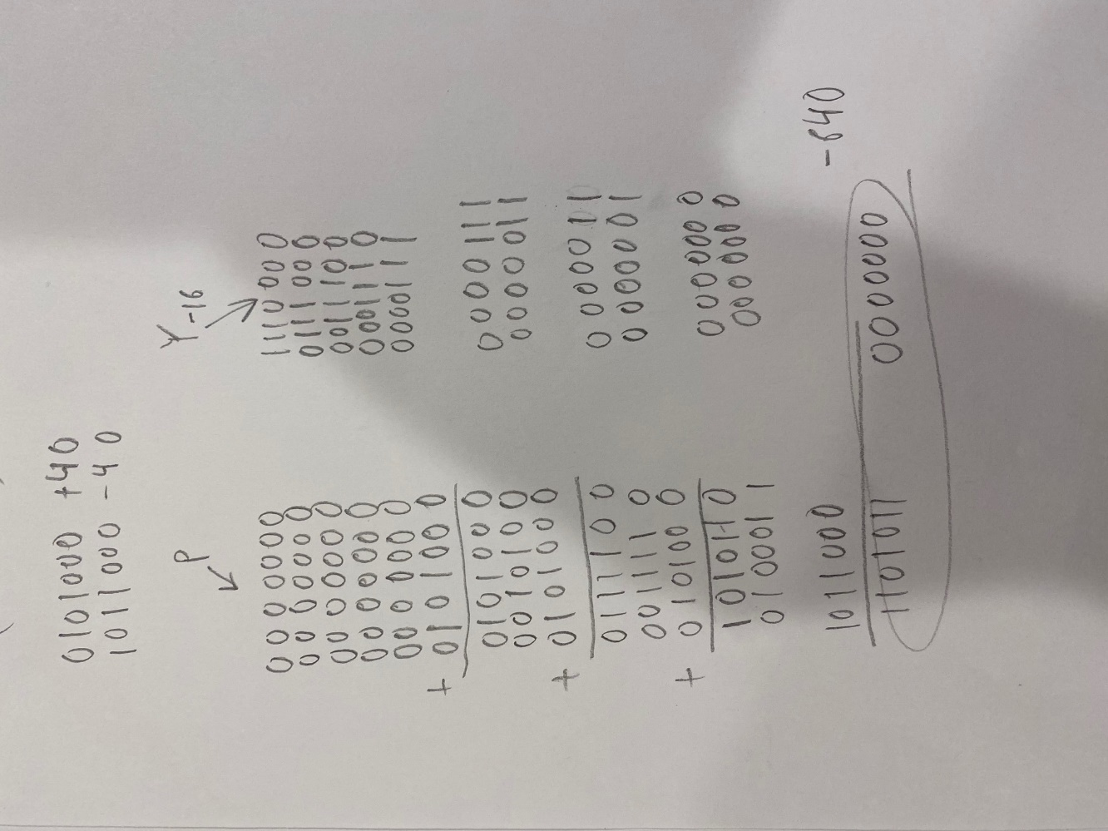

Use the restoring algorithm 58/13

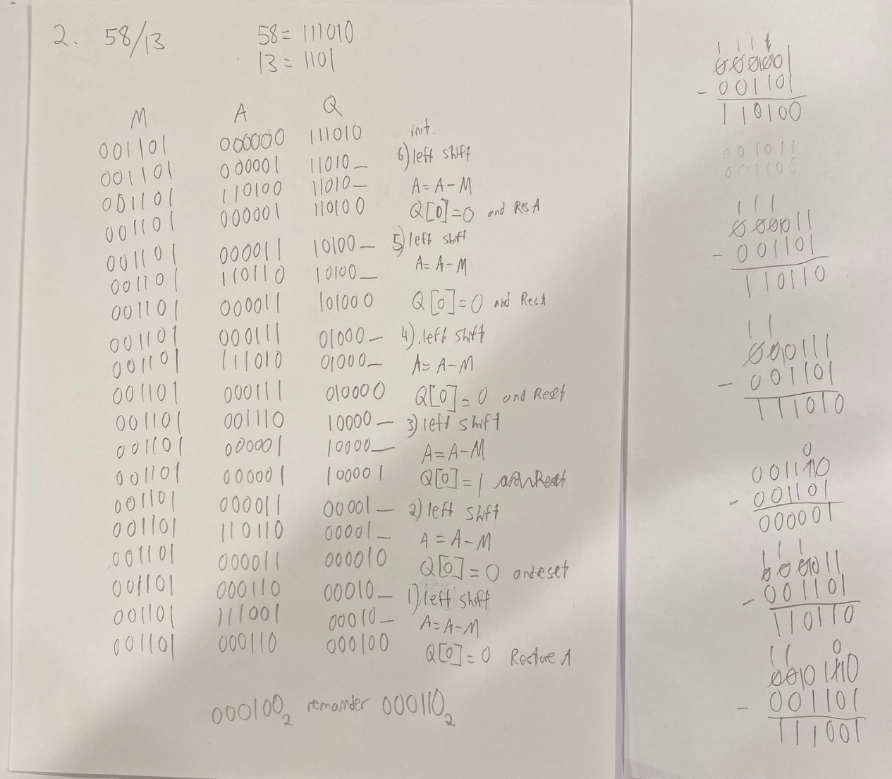

Use the restoring algorithm 85/27

